MACH4METAL

metalworking machinery
Transito 21
6909 DA BABBERICH Netherlands
Tel. +31 (0)316-247123
Fax: +31 (0)316-247956
info@mach4metal.com
www.mach4metal.com

Bank No : 66.52.13.883
IBAN : NL33 INGB 0665 2138 83
BIC : INGBNL2A

LEIFELD PNC 106 spinning
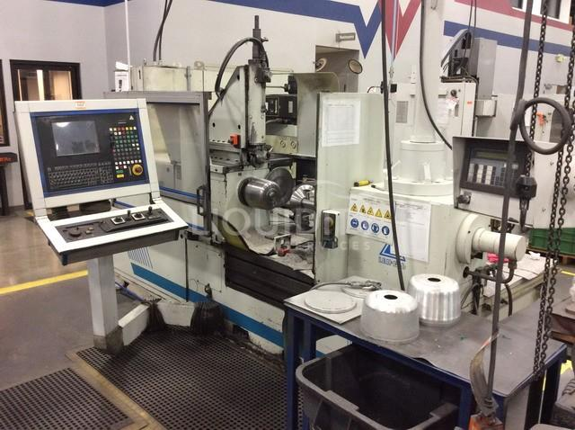
- Make : Leifeld Germany
- Typ : PNC 106
- Age : 200…
- Serial : 10 . 3320 . 0

- Centre height : 350
- Max. swing Ø : 700
- Max. length : 800
- Max. steel : 3 mm

- Support stroke X : 425
- Power X Travel : 15 Kn
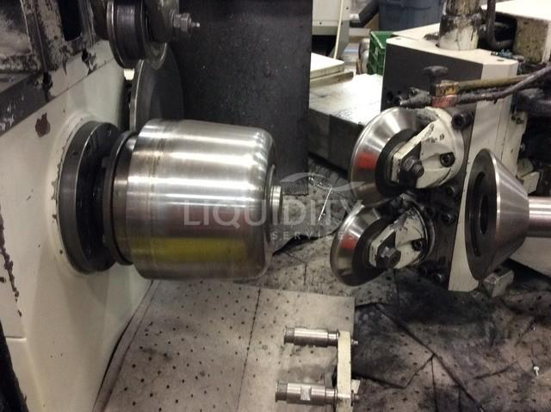

- Support cross Z : 400
- Power Z Travel : 15 Kn

- Force support X : 28 kN
- Force support Z : 28 kN

- Stroke ejector : 200 mm
- Tail stock stroke : 450 mm

- Power : 7.5 kW
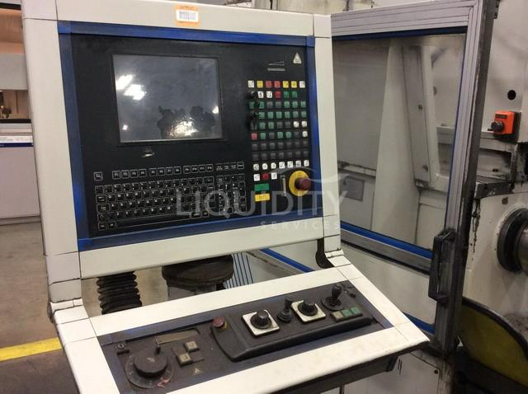
- Spindle head : DIN 55027 – Gr.6
- Spindle speeds : 3800 RPm ?

- Leifeld LEICO PNC CNC
- System unit Leifeld KA ?
- System unit Leifeld BAE I ?

Please Note: The above information has been obtained to the best of our ability and belief from, and from the manufacturers where possible. It is given in good faith, but its accuracy can not be guaranteed. Accordingly, it will not form a representation or constitute contractual terms. We advise you to check any vital details!

